Year 9 Revision – Acids and Bases Name: ________________________

- How do acids taste and feel?
- Give 3 examples of acids.

- What happens when a metal like magnesium is placed in a test tube of acid? Which gas is produced?

- Why are acids dangerous?

- All acids contain ______________ that will be released in solution to give the acidic properties.
- Name some acids found in food and drinks.
_________________________, __________________________, ______________________,
_________________________, __________________________, ______________________,
- Explain the difference between a strong and a weak acid.

- Name a strong acid: ______________________ and a weak acid: ______________________.
- How do bases taste and feel?
- Name 4 common bases at home and give their uses.
______________________ ___________________________________________________
______________________ ___________________________________________________
______________________ ___________________________________________________
______________________ ___________________________________________________

- What should you do when you have a spillage of acid or base on your skin?

- What is the meaning of neutralisation?
- Why do we use toothpaste, which is a base, for cleaning teeth?

- Which acid is found in our stomach? Which chemical can be taken to neutralise excess acid in the stomach?

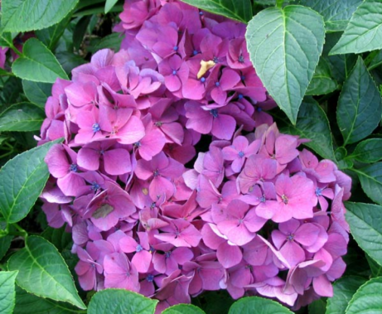
- Hydrangea appears as different colours in different pH levels of soil. Why?

- What is an “Indicator”?

- Name 3 indicators.
- Litmus paper is used to test for acid or base.
Blue litmus → Red indicates the solution is ________________(acidic/basic)
Red litmus → Blue indicates the solution is ________________(acidic/basic)

- If a solution does not change the colour of the red litmus, what can you tell about this solution?
- Why is pH paper a better choice than litmus paper?

- In term of acidity, what is the difference between pH 1 and pH 5?

- Which pH indicates a neutral substance?

